Classroom Lesson Plan
Lesson Title | Grade Range | Time Needed
Gender and Career Choice | 9 | 45 minutes

Domain | Mindset Standards | Behavior Standards
Career | 2, 5 | SMS: 10, SS4

Learning Objectives:
- Discuss traditional male and female careers
- Examine how career choice may be influenced by gender
- Use critical thinking and writing skills
Supplies/Materials:
- Men and Women signs – 3 of them (attached)
- Career list (attached)
- Sticky notes
- Career list (attached)
- Box
- Copies of “Skills Sets for Nontraditional Careers” for students (found at http://www.iseek.org/careers/skillsets.html and also copied & pasted below in attachment)
Outline:
- As students come in, give each student 2 sticky notes. On one sticky note the teacher will write one career from the Career List (attached). On the other sticky note, have the student write a career he/she is interested in pursuing.
- Hang up the men and women signs on opposite walls of the classroom and ask students to place their sticky notes under the men sign if the job is typically held by men or under the women sign if it is traditionally held by women. If a student feels the job is neutral, have him/her place it under the sign with both figures.
- Pull a sticky note from each sign and discuss the following questions. Then, if applicable, move the note to the gender neutral sign. Do this for several sticky notes.
  - Discussion questions:
    - Why do you think this career is mostly filled by men (women0?
    - Could anyone do this job or are there restrictions based on gender?
    - Why would a man (woman) consider this as a career?
    - Should gender always determine career or job choice?
- Distribute the “Skills Sets for Nontraditional Careers” sheet to students and discuss the information with students.
- OPTIONAL ACTIVITY: Have students complete the Nontraditional Quiz online at http://www.iseek.org/iseek/_media/quiz/nontrad/Nontrad_quiz.html)
PROCESS QUESTIONS:
- Were you surprised by anything discussed in this lesson?
- How do you look at careers and their relation to gender?
- Why do you think more women don’t pursue male-dominated careers and vice versa?

Adapted from: Hodges, D. (n.d.). Gender and career choice.

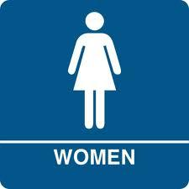
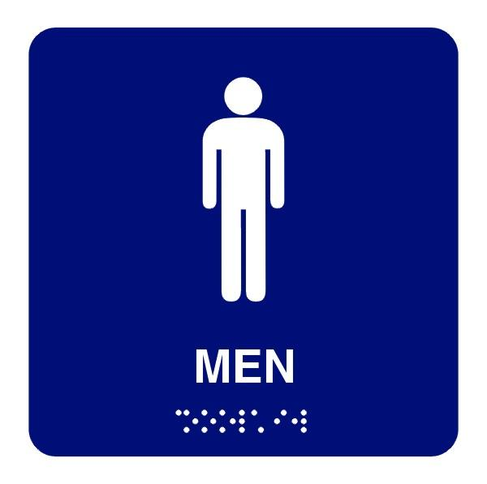
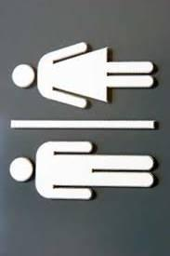

Career List

Carpenter |  | Preschool Teacher
Video Game Designer |  | Rock DJ
Park Ranger |  | Legal Secretary
Dentist |  | Farmer
Medical Assistant |  | Electrician
Forklift Operator |  | Cable Installer
Bank Manager |  | Physical Therapist
Photographer |  | Checkout Clerk
Engineer |  | Fire Fighter
Auto Mechanic |  | Hair Stylist
Nurse |  | Judge
Engineer |  | Wedding Planner
Insurance Agent |  | Professor
Mental Health Counselor |  | Veterinarian
Sales Clerk |  | Pharmacist
Locksmith |  | Security Guard
Concrete Finisher |  | Cabinet Maker
Interior Designer |  | Financial Manager

(http://www.iseek.org/careers/skillsets.html)

Skills Sets in Nontraditional Careers
Job requirements have little or nothing to do with gender.
In fact, skill requirements in male- and female-dominated occupations are often more similar than you might think.

Different Genders, Same Skills
People sometimes avoid nontraditional careers because of who works in them and not what the job would actually be like. But did you know that some male-dominated careers use the same skills as some female-dominated ones?

Skill Profiles
Skill profiles are graphs of which skills are most or least required by occupations. Learn how similar occupations are to each other by comparing their skill profiles. You may find some surprises, such as:
- The skill profile (409KB, .pdf) for registered nurses (92% female) is similar to those for civil engineers (11% female).
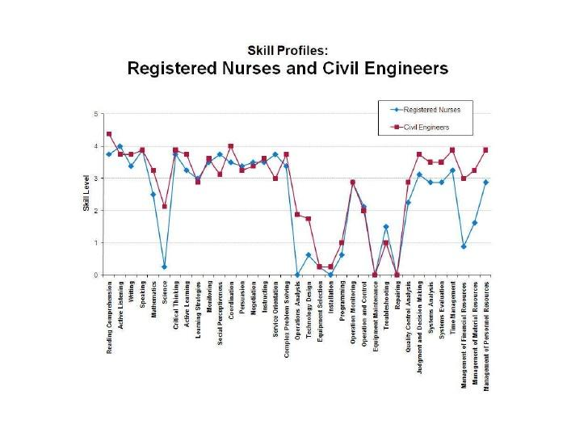
- The skill profile (482KB, .pdf) for construction managers (6% female) is similar to those for meeting and convention planners (80% female).
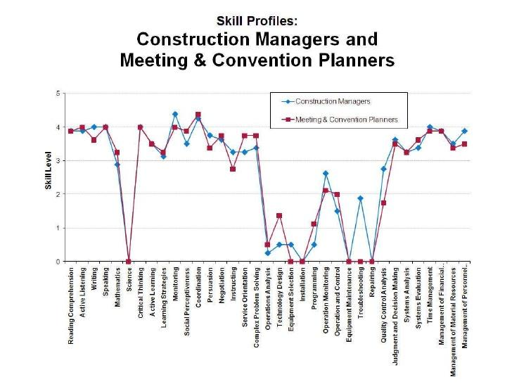
- The skill profile (500KB, .pdf) for firefighters (4% female) is similar to those for personal and home care aides (87% female).
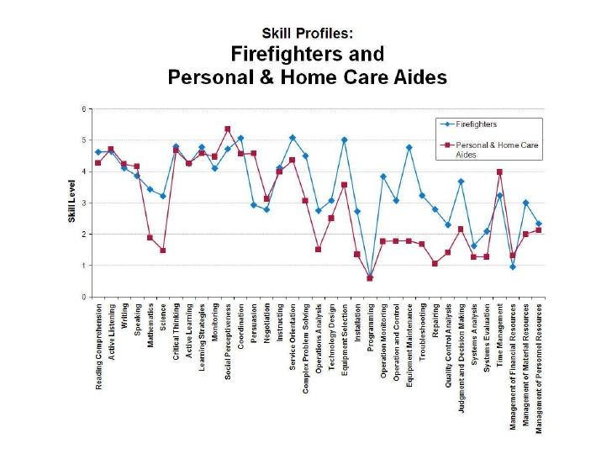
Skills Profiles

Don't Let Strength Requirements Deter You
Some women think they won't qualify for nontraditional careers due to physical requirements. But such requirements are often overstated.
It's true that some male-dominated occupations require more strength than female-dominated occupations (see the chart below). But the differences aren't as large as you might think. So don't limit your options because of incorrect facts.
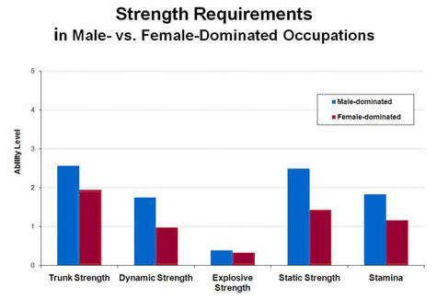

Bona Fide Occupational Qualifications
A company is legally able to specify that a certain job must be filled by a man or woman. In these cases, sex is a bona fide occupational qualification (BFOQ). There are no standard BFOQ occupations. Employers have to make the case that a job qualifies for this status.
But BFOQs are not common. For example, sex isn't a BFOQ for jobs with manual tasks or lifting (which are often filled by men). Nor are jobs that require nurturing or caretaking (which are often filled by women). Applicant must be judged on their individual abilities. They cannot be judged on what is typical for their group.

